Oliver Collins-Cope

2102775@rutc.ac.uk

Learning Aim B & C

Carry out project initiation for an IT project and carry out the planning, execution, monitoring, and controlling an IT project, using an appropriate methodology

UNIT 9 IT PROJECT MANAGEMENT

Assignment 2

Contents

Introduction 3

Project idea generation and solution creation 3

Project IT Problem 3

Creativity tools to solve problems 4

Solution 4

First alternative solution 4

Second alternative solution 4

Feasibility study for solution 4

Technical assessment 4

Economic assessment 4

Legal assessment 4

Operational assessment 4

Scheduling assessment 4

Sustainability assessment 4

Security assessment 4

Usability assessment 4

Feasibility study for alternative solution 4

Technical assessment 4

Economic assessment 4

Legal assessment 4

Operational assessment 4

Scheduling assessment 4

Sustainability assessment 4

Security assessment 4

Usability assessment 4

Project Requirements 4

Project Phasing 4

Functional and non-functional requirements 4

Requirement specification documentation 4

Typical project management process 4

Planning project management processes 4

Risk and issue processes 4

Execution and management processes 4

Monitoring project management processes 4

Conclusion 4

# Introduction

# Project idea generation and solution creation

## Project IT Problem

In my IT project where I am designing a traffic light mobile application, I have chosen to use the Unity game engine in order to successfully complete this and achieve an adequate outcome with my application. This means that all of the interfacing and coding will be done in C# and Unity respectively, and through this I will eventually be able to make my application successfully meet the criteria that was required.

Unfortunately, Unity is lacking in any kind of version control or cloud back up software. Version control, also known as source control, is the practice of managing and tracking different changes to software. This can either be things like code or interactive elements in some choice scenarios like a game engine. The ability to track changes and keep a log of when they happened is an integral part of developing code, as it allows efficient troubleshooting and crucial rollbacks to working versions of the code if a bug is introduced that has devastating effects. This also allows programmers/developers to track when changes are introduced and potentially identify and bugs like this, further proving that version control/source control software is crucial when developing.

This presents the final issue that has to be resolved. Due to the fact that there is no version control that comes with Unity, I will have to look at other software that enables me to do this. Fortunately, there are many solutions available, ranging from extensions to Unity or switching software completely, and this will be adequately researched and discussed below.

### Creativity tools to solve problems

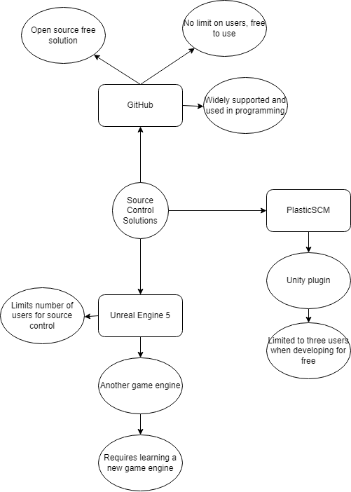

### Solution

Due to the nature of creating an application in Unity, I plan to implement source control to allow multiple members of the team to work on the project without having to rely on a convoluted way of tracking progress and giving each other the most updated version of the project.

My first and most likely solution that I have chosen for this is to use Github as my source control software. Github is a version control software, that “helps developers track and manage changes to the software projects code.” (Kinsta, 2022) It is widely used in software development as a way to manage source control, and is perfect for this small project that has an even smaller team to develop it.

Furthermore, Github is completely free and getting setup and started with it is relatively simple as it offers both GUI application options and CLI terminal based operations which allows the user to fully optimise their experience and use Github to the best of their abilities.

### First alternative solution

An alternative to Github could be to use PlasticSCM. PlasticSCM is “Plastic SCM is a version control system optimized for game development and 3D projects, and as such, it supports separate workflows within the same repo.” (Unity, 2023)

This means that PlasticSCM is used with Unity in order to allow for version control software. On the other hand, while this means that the version control software will be all inside of Unity, it is likely that developers will have to expand and learn new skills in order to be able to use this, which is not favourable when considering deadlines and timescales.

Finally, PlasticSCM limits it’s free options to just three free members, before charging for each additional member, meaning that it could become very expensive for such a small scale project that will likely not generate much revenue.

### Second alternative solution

Finally, the third alternative solution to using Github and PlasticSCM, is to use another game engine called Unreal Engine, and develop the mobile application for the traffic light in there.

The source control for Unreal Engine is built into the program, and can be activated by going through the content browser or the level editor’s preference window. Within Unreal Engine (UE), “Source control is used to manage changes over time to code and data, and enables teams to coordinate their game development efforts.” (Unreal Engine, 2023)

Unreal engine source control is free to use for users although it does require some setup and therefore might require some time and assistance when establishing, and therefore is an effective alternative solution to the above mentioned two source control options.

# Feasibility study for solution

## Technical assessment

## Economic assessment

## Legal assessment

## Operational assessment

## Scheduling assessment

## Sustainability assessment

## Security assessment

## Usability assessment

# Feasibility study for alternative solution

## Technical assessment

## Economic assessment

## Legal assessment

## Operational assessment

## Scheduling assessment

## Sustainability assessment

## Security assessment

## Usability assessment

# Project Requirements

# Project Phasing

## Functional and non-functional requirements

## Requirement specification documentation

# Typical project management process

## Planning project management processes

Hiring people etc

Gantt chart

Communication platform

## Risk and issue processes

## Execution and management processes

## Monitoring project management processes

# Conclusion